A taste of German

In which 6 countries German is the official language? Discuss with your partner!

1.___________ 2.___________3.___________4.__________5._________6.___________

Impressions of German speaking countries. Which picture matches which country?

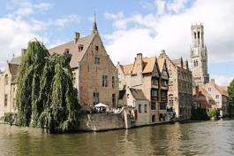
This is (name of the country)_____________________.

This is (name of the country)_____________________.
This is (name of the country)_____________________.
This is (name of the country)_____________________. This is (name of the country)_____________________.
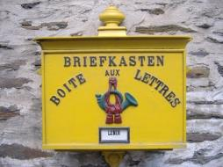

This is (name of the country)_____________________.
Source of pictures: Pixabay www.pixabay.com

Which word matches which picture? Try to find out. First match the words you are pretty sure of and try to find out the others by excluding.
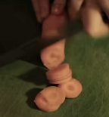
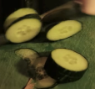
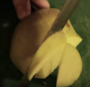
Wassermelonen

Mandarinen

Gurken
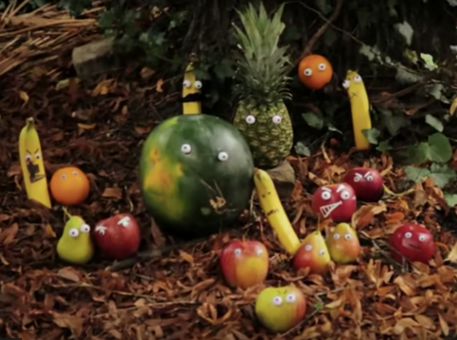

Birnen

Äpfel

Kartoffeln

Ananas

Bananen

Karotten

Source of pictures: Screenshots of the video from “Deine Freunde”
https://www.youtube.com/watch?v=Va2nGWTchBk

Hypotheses!

How is the plural often constructed in German?

__________________________________________________________________________

More precisely, when is that the case?

__________________________________________________________________________

Let’s talk! Speak with your partner.

Ich mag __________.

Magst du ______?

Ja, ich mag _____ .

Nein, ich mag keine _____.
Hypotheses!

Ich mag/ du magst means: _____________

Questions start with: ________

”keine” means ____________

Tasks for the video

Watch the video clip of “Meine Freunde”, without sound!, until minute 0:48.
https://www.youtube.com/watch?v=Va2nGWTchBk

- What do you think – Is the man in the video happy or unhappy?

- Why do you think is that the case?

- At the end of this clip, at minute 0:48, one man is pulling on a string (see picture): What do you think will happen next?

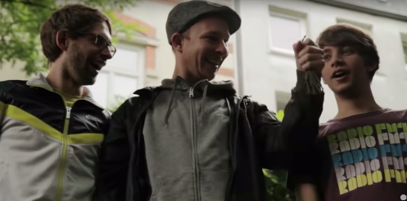

Next scene

The friends are now in a new setting. Are there any clues which make you think this looking at the photo in the presentation?

Watch out, there are more questions in the presentation!

Sound check!

Listen now from the beginning – with sound! Do you recognise any of our other words? Underline the words you hear!

Kartoffeln, Ananas, Bananen, Karotten, Äpfel, Birnen, Gurken, Mandarinen, Wassermelonen

Did you like it? Speak with your partner and then in class.

Question: Magst du das Lied?

Answer: Ja. / Nein.

Ja, ich finde das Lied gut/ cool/ lustig.

Nein, ich finde das Lied blöd/ uncool/ eklig.

Listening challenge

Are you a good listener? Challenge yourself with the Lyrics Training App.

Go to: https://lyricstraining.com/app

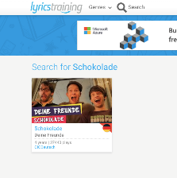 1. Search for the song.

2. Select “Beginner”.

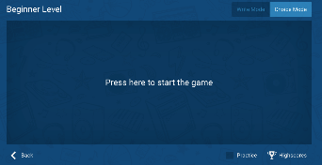 3. Select “Choice Mode”.
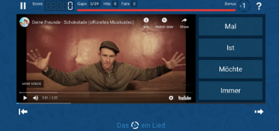

4. Choose the words which fill in the gap and have fun!

